**REQUIREMENT GATHERING FOR THE AUTOMATION OF**

**AUN FACULTY-COURSE EVALUATION (FCE)**

**The Manual System:**

The AUN FCE has been used in the past as a document for evaluating faculty teaching effectiveness. It assesses the relevance of a course and its content to a particular programme in the University. It is also used to evaluate the usefulness of teaching aids (e.g. writing center and math lab) to students taking such courses.

For each course, FCE instruments are usually administered to students two weeks to the end of every semester. The process involves dispatching questionnaires from the Office of Institutional Research and Effectiveness (OIRE) to the office of the Dean of each school (except Post Graduate?). A staff person from the Deans’ office would assume responsibility for final dispatch to students based on class schedules. All questionnaires are thereafter returned sealed to ORIE for final processing.

The final processing involves tedious data entry on a pre-formulated spread sheet. Calculations are based on averages, with provisions made to capture students’ comments. A summarized portion of the sheet is thereafter captured and printed to produce results of the evaluation for the semester. Duplicate copies of the results are prepared and sent to the Deans; with a copy for the Dean and one for the Faculty.

**Disadvantage of the Manual System**

Like every other non-automated system, the FCE has it disadvantages, these:

1. The processes are tedious
2. It is costly in terms of paper and toner usage
3. It requires time to prepare results
4. It is prone to error

**The Proposed Automated System**

The proposed automated system shall be an online system

**System Requirements and Processes:**

The proposed system should run on a server and the data should be captured online, processed and stored in a database. The designed questionnaire (FCE Form) should be mapped to each student as s/he registers a course. The questionnaire should be activated towards the end of the semester or whenever the school decides appropriate to administer the evaluation. The questionnaires would be accessible from any computing device to students registered for and still enrolled on a course as at the time the evaluation is active.

**Requirements:**

The primary users of the system include: Students, School Administrators (Dean, Provost), Faculty and an Administrator. Each category of user (except the administrator) shall be have limited access rights to the system functionality.

**Students (Primary User)** Students should be to:

* login with their credentials (User ID and Password) at the close of classes and have access to complete evaluations for each course for which they are registered and not marked as withdrawn (WP, WF).
* provide course feedback by completing the questionnaire.
* submit the questionnaire after completion
* see which courses for which evaluations are outstanding
* review and edit their inputs before final submission
* view historical evaluations they have completed and they date of completion by semester
* receive notifications by email on outstanding evaluations and the closing date to complete

Students should **NOT** be able to:

* modify their access privileges to the system
* view the final/compiled result of the faculty/course evaluated

**Faculty** should be able to**:**

* login with his credentials (User ID and Password)
* view results of students’ feedback for courses they are teaching that semester
* view historical results of course evaluations for courses taught in previous semesters
* view aggregate of comments made by students for a particular course for a given semester

**School Administrators (Deans, AVP, President)**

* Deans should have access to results for all Faculty in their school irrespective of courses they are teaching (courses could be in other schools)
* Deans should have access to results for all Courses in their school irrespective of the department the teaching Faculty is in.
* Deans should have access to historical results for faculty by semester
* AVP and President should have access to **ALL** results for all faculty and all schools
* AVP and President should be able to drill down to individual evaluation forms from the aggregate results for a given faculty for a given semester

**Administrator (Super User)**

* The administrator should have the right to setup, edit and tear down questionnaires as the need arises.
* Administrator should be able to view results from feedbacks made by students.
* Administrator should be able to activate and deactivate evaluations.
* The Administrator should be able to download summarized and detailed results of students’ feedback.
* Administrator should be given access right to export results (data) to other statistical tools, if need be for further analysis.

**Functional Requirement**

**Use Cases**

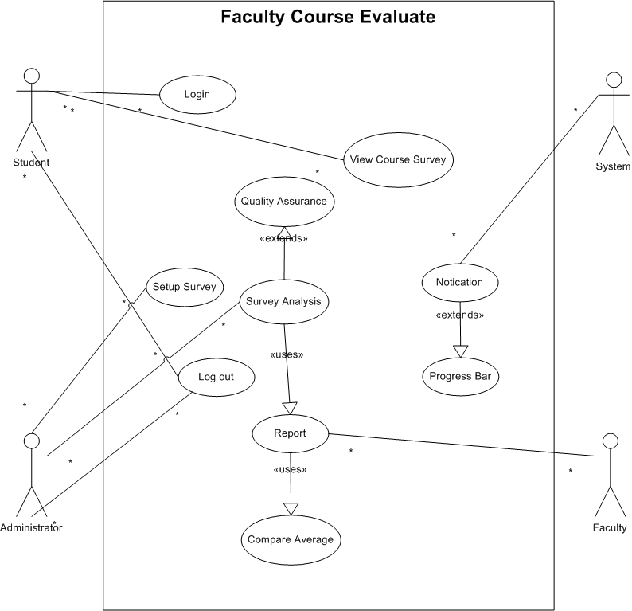

***UC1***: Setup Survey

***Primary Actor***: Administrator

***Precondition***: Administrator most be logged in

***Main Success Scenario:***

1. Enter name of the Survey
2. Enter description of the survey
3. Build/Reuse Survey
4. Set the Start and End date/time for the survey
5. Send Survey to everyone or a selected group

***Exception Scenario***:

1. Less than 50% of the survey is filled and survey time is over

* System should allow the administrator to extend date if necessary

***UC2***: View Course Survey

***Primary Actor***: Students

***Precondition***: Students must be logged in

***Main Success Scenario***:

1. See a list of Course take in the semester
2. See Progress bar of the surveys in the view
3. Enter desired course
4. Fill the survey
5. Save changes to survey
6. See Progress bar of current surveys
7. Submit survey when filled

***Exception Scenario:***

1. Student has dropped some courses before the survey start

* System shouldn’t display this course

1. Survey data can’t be changed after submission

* System should disable courses with submitted surveys.

***UC3:*** Notification

***Primary Actor***: System

***Precondition:*** Survey setup is complete

***Main Success Scenario:***

1. Send notification Email to students associated to the survey when it starts
2. At half way through and also some moment (12hours) before the end send notification to students on progress report
3. Send notification to student that are done with their survey

***Exception Scenario:***

1. When student have completed the survey

* System should only send notification to them immediately and once.

***UC4***: Progress Bar

***Primary Actor:*** Student, Administrator

***Precondition:*** Systems User are Logged in

***Main Success Scenario:***

1. Student should see the progress bar indicating how much he/she has filled on the courses
2. Administrator should be able to see percentage of completed survey per course
3. Administrator should be able to see an average of completion for all the course

***Exception Scenario:*** none

***UC5:*** Survey Analysis

***Primary Actor:*** Administrator

***Precondition:*** Survey End date has passed

***Main Success Scenario:***

1. View old and new survey record by term
2. Export any of the select survey in csv, json, xml, excel etc
3. View average of an indicator for a course by faculty
4. View average of an indicator for all courses by faculty
5. View average of an indicator for all student
6. View average of an indicator for all student in a particular school
7. View average of an indicator for a major in a course.
8. View average of an indicator for all course taken by a major
9. View some of the averages against each other
10. View averages of faculty against each other.
11. View averages of courses against each other.

***Exception Scenario:*** none

***UC6:*** Report

***Primary Actor:*** Faculty

***Precondition:*** Logged In

***Main Success Scenario:***

1. View average of an indicator for all his/her courses
2. View average of an indicator for a course he/she is taken
3. View average of an indicator for all course with the same name that the faculty Is taken
4. View average against each other

***Exception Scenario:*** none

***UC7:*** Quality assurance

***Primary Actor:*** System

***Precondition:*** After the survey is closed

***Main Success Scenario:***

1. All student with the same rate for all indicators should be remove from the data analysis and Export

***Exception Scenario:*** none

***UC8***: Compare Averages

***Primary Actor:*** Administrator, Faculty

***Precondition:*** Logged into the system

***Main Success Scenario***:

1. View different series of average against each other
2. Faculty compare differently view averages available to him/her
3. Administrator compare differently viewed averages available to him/her

***Exception Scenario***: none